STREET GUARD

Your Safety Our Responsibility

**Street Guard: Your Safety Our Responsibility**

**Introduction**

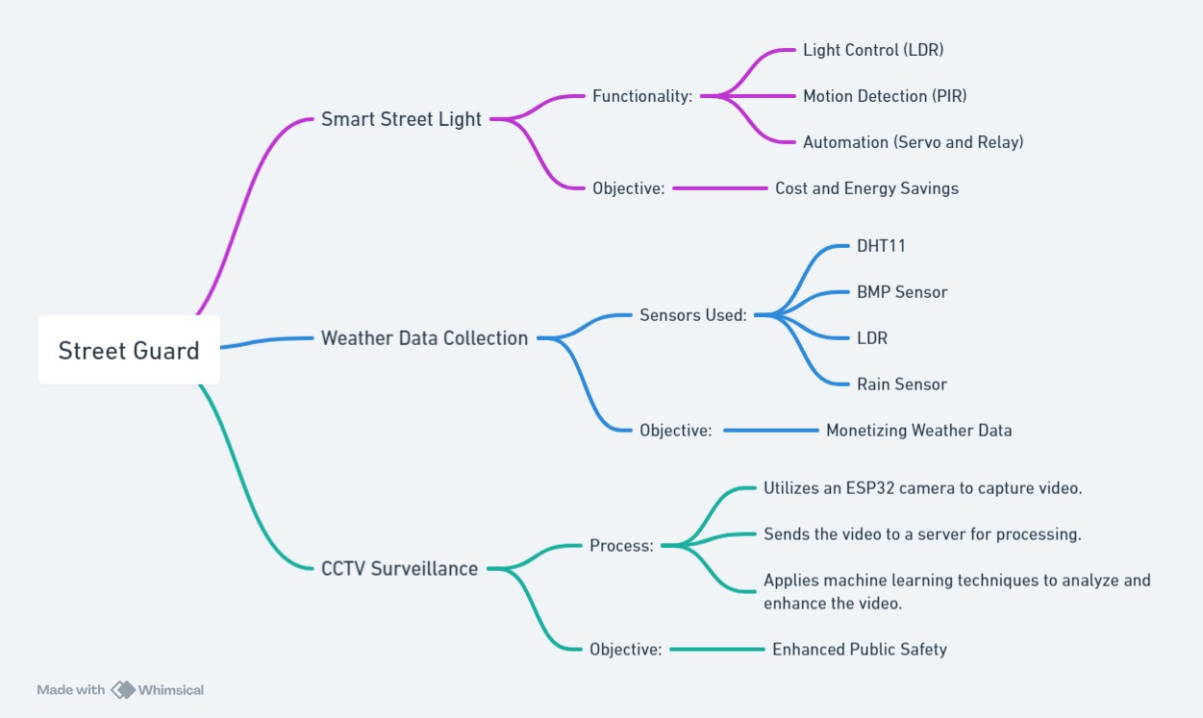

Street Guard is an innovative IoT project designed to enhance street safety, monitoring, and management through a combination of advanced sensors, cloud computing, and machine learning. The project focuses on three main areas:

1. **Accurate Weather Monitoring**
2. **Remote Street Light Management**
3. **Enhanced CCTV Surveillance**

Additionally, Street Guard includes an admin panel that allows administrators to control all system functions. There are two modes available for managing the system: manual and automated.

This report outlines the key features, components, and functionalities of the Street Guard system, providing a comprehensive overview of how it operates and its benefits.

**Accurate Weather Monitoring**

Street Guard utilizes a range of sensors to collect detailed weather data. These include:

* **Temperature Sensors (BMP180 and DHT11)**: Measure ambient temperature.
* **Humidity Sensor (DHT11)**: Monitors the humidity level.
* **Rain Sensor**: Detects precipitation levels.
* **Pressure Sensor (BMP180)**: Measures atmospheric pressure.

The collected data is transmitted to an IoT server, providing precise local weather information. This data can be used to optimize various street management tasks, such as adjusting street light intensity and planning maintenance schedules.

**Temperature Sensors**

The BMP180 sensor is a high-precision barometric pressure sensor that can also measure temperature. It provides accurate readings of the ambient temperature, which can be crucial for adjusting street light brightness and scheduling maintenance activities. The DHT11 sensor is another temperature sensor used in the Street Guard system. It provides additional temperature data and ensures redundancy in the system, enhancing reliability.

**Humidity Sensor**

The DHT11 sensor also functions as a humidity sensor. It measures the relative humidity in the air, which can affect the comfort and safety of pedestrians and vehicles. By monitoring humidity levels, Street Guard can adjust street lighting and other systems to ensure optimal conditions.

**Rain Sensor**

The rain sensor detects precipitation levels, providing real-time data on rainfall. This information is essential for adjusting street light intensity and scheduling maintenance activities. For example, during heavy rain, street lights can be set to a higher intensity to improve visibility and safety.

**Pressure Sensor**

The BMP180 sensor also measures atmospheric pressure, providing valuable data on weather conditions. Changes in atmospheric pressure can indicate upcoming weather changes, such as storms or clear skies. This information can be used to adjust street lighting and other systems accordingly.

**Remote Street Light Management**

Street Guard enables remote control and automation of street lights through IoT and cloud services. Key functionalities include:

* **Light Intensity Adjustment**: The system can adjust street light brightness based on real-time traffic conditions and ambient light levels.
* **Manual and Automated Modes**: Users can switch between manual and automated modes for controlling the lights.
* **Energy Efficiency**: By dynamically adjusting light intensity, the system reduces energy consumption and extends the lifespan of street lights.

**Light Intensity Adjustment**

Street Guard uses light sensors and traffic data to adjust the brightness of street lights in real-time. By monitoring ambient light levels and traffic conditions, the system can determine the optimal light intensity for each street light. For example, during periods of low traffic, street lights can be dimmed to save energy, while during peak traffic hours, lights can be set to higher intensities for improved visibility and safety.

**Manual and Automated Modes**

The admin panel allows users to switch between manual and automated modes for controlling the street lights. In manual mode, administrators can set the light intensity and other parameters directly. In automated mode, the system uses sensor data and predefined algorithms to adjust the lights automatically. This flexibility allows for both hands-on control and efficient automation.

**Energy Efficiency**

By dynamically adjusting light intensity based on real-time data, Street Guard significantly reduces energy consumption. This not only lowers operational costs but also contributes to environmental sustainability. Additionally, the system's ability to adjust light intensity based on traffic conditions ensures that street lights are used efficiently, reducing unnecessary wear and tear and extending their lifespan.

**Enhanced CCTV Surveillance**

Street Guard integrates enhanced CCTV surveillance capabilities to improve street security. This includes:

* **Live Camera Feeds**: Continuous monitoring through live camera feeds.
* **Machine Learning**: Advanced image processing and analysis for identifying potential security threats and unusual activities.

**Live Camera Feeds**

Street Guard provides continuous monitoring through live camera feeds. These feeds can be accessed remotely through the admin panel, allowing administrators to monitor street conditions in real-time. The live camera feeds are essential for identifying security threats, monitoring traffic conditions, and ensuring the safety of pedestrians and vehicles.

**Machine Learning**

The system uses machine learning algorithms to analyze the live camera feeds and identify potential security threats and unusual activities. For example, the algorithms can detect suspicious behavior, such as loitering or vandalism, and send alerts to the admin panel. This advanced image processing capability enhances the effectiveness of the surveillance system and improves overall street security.

**Admin Panel**

The admin panel is a crucial component of Street Guard, allowing administrators to control all aspects of the system. Through the admin panel, administrators can:

* Switch between manual and automated modes.
* Monitor real-time weather data and street conditions.
* Adjust street light settings and intensities.
* Access live CCTV feeds and review surveillance footage.
* Receive alerts and notifications for unusual activities or system issues.

**User Interface**

The admin panel features an intuitive user interface that makes it easy for administrators to manage the system. The interface displays real-time data on weather conditions, street light settings, and surveillance feeds, providing a comprehensive overview of the system's status. Administrators can easily switch between manual and automated modes, adjust settings, and view live and recorded camera footage.

**Alerts and Notifications**

The admin panel provides alerts and notifications for unusual activities or system issues. For example, if the machine learning algorithms detect suspicious behavior on the CCTV feeds, the system sends an alert to the admin panel. Similarly, if a sensor malfunctions or a street light goes out, the system notifies the administrator. These alerts and notifications ensure that administrators can respond quickly to any issues.

**Hardware Components**

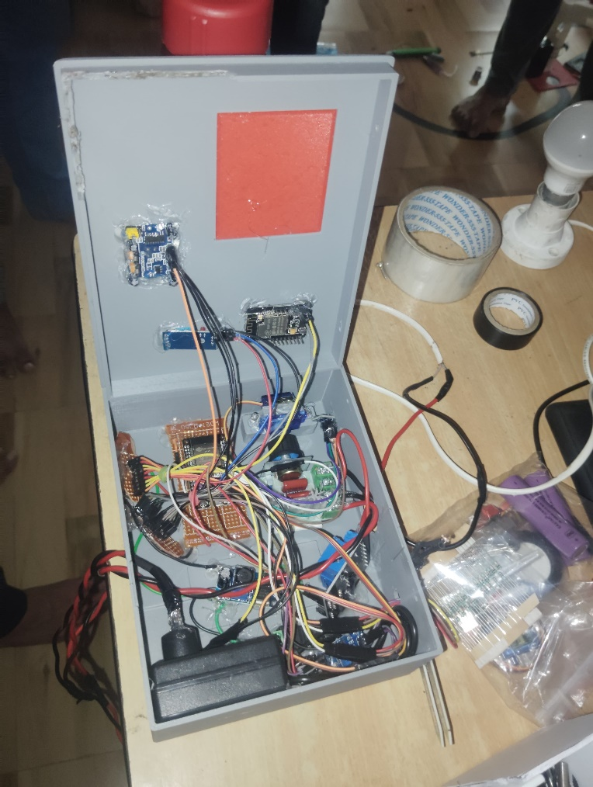

Street Guard is built using a combination of sensors, microcontrollers, and other hardware components. The key hardware components include:

**ESP32 Microcontroller**

The ESP32 microcontroller is the core of the Street Guard system. It is responsible for data processing and communication with the sensors, actuators, and cloud services. The ESP32 features built-in Wi-Fi and Bluetooth, making it ideal for IoT applications. It processes data from the sensors, controls the actuators, and communicates with the admin panel and IoT server.

**Sensors**

Street Guard uses a variety of sensors to collect weather data and monitor street conditions. These sensors include:

* **BMP180**: Measures temperature and atmospheric pressure.
* **DHT11**: Measures temperature and humidity.
* **Rain Sensor**: Detects precipitation levels.
* **Light Sensor**: Measures ambient light levels.
* **PIR Sensor**: Detects motion and presence of pedestrians and vehicles.

**Servo Motor**

The servo motor controls the orientation of the street lights. It adjusts the direction of the lights based on real-time data, ensuring optimal illumination of the streets. The servo motor can be controlled remotely through the admin panel, allowing administrators to adjust the light direction as needed.

**Relay**

The relay manages the on/off state of the street lights. It switches the lights on or off based on real-time data from the sensors and commands from the admin panel. The relay is a critical component for implementing energy-efficient street light management.

**CCTV Cameras**

Street Guard includes CCTV cameras for live surveillance feeds. These cameras provide continuous monitoring of the streets, allowing administrators to view real-time footage and review recorded footage. The cameras are connected to the ESP32 microcontroller, which processes the video data and transmits it to the admin panel.

**Software Components**

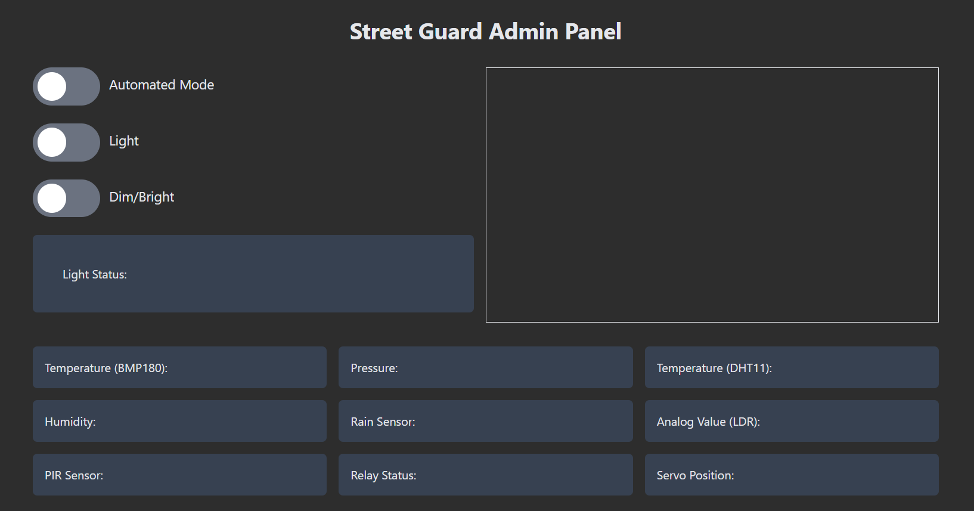

Street Guard uses various software components to manage the sensors, actuators, and cloud services. The key software components include:

**Arduino IDE**

The Arduino IDE is used for programming the ESP32 microcontroller. It provides a user-friendly interface for writing, compiling, and uploading code to the microcontroller. The Arduino IDE supports various libraries and extensions, making it easy to integrate the sensors, actuators, and cloud services with the ESP32.

**Adafruit BMP085 Library**

The Adafruit BMP085 library is used to interface with the BMP180 sensor. It provides functions for reading temperature and atmospheric pressure data from the sensor. The library simplifies the process of integrating the BMP180 sensor with the ESP32 microcontroller.

**DHT Library**

The DHT library is used to interface with the DHT11 sensor. It provides functions for reading temperature and humidity data from the sensor. The library makes it easy to integrate the DHT11 sensor with the ESP32 microcontroller.

**ESPAsyncWebServer**

The ESPAsyncWebServer library is used to set up a web server on the ESP32 microcontroller. It allows administrators to access the admin panel and control the Street Guard system remotely. The library supports various web protocols and provides functions for handling HTTP requests and responses.

**ThingSpeak**

ThingSpeak is an IoT platform used for data visualization and analysis. It provides a cloud-based service for storing, analyzing, and visualizing data from IoT devices. Street Guard uses ThingSpeak to store and analyze weather data collected by the sensors. The platform provides real-time data visualization and analytics, making it easy to monitor and analyze weather conditions.

**System Architecture**

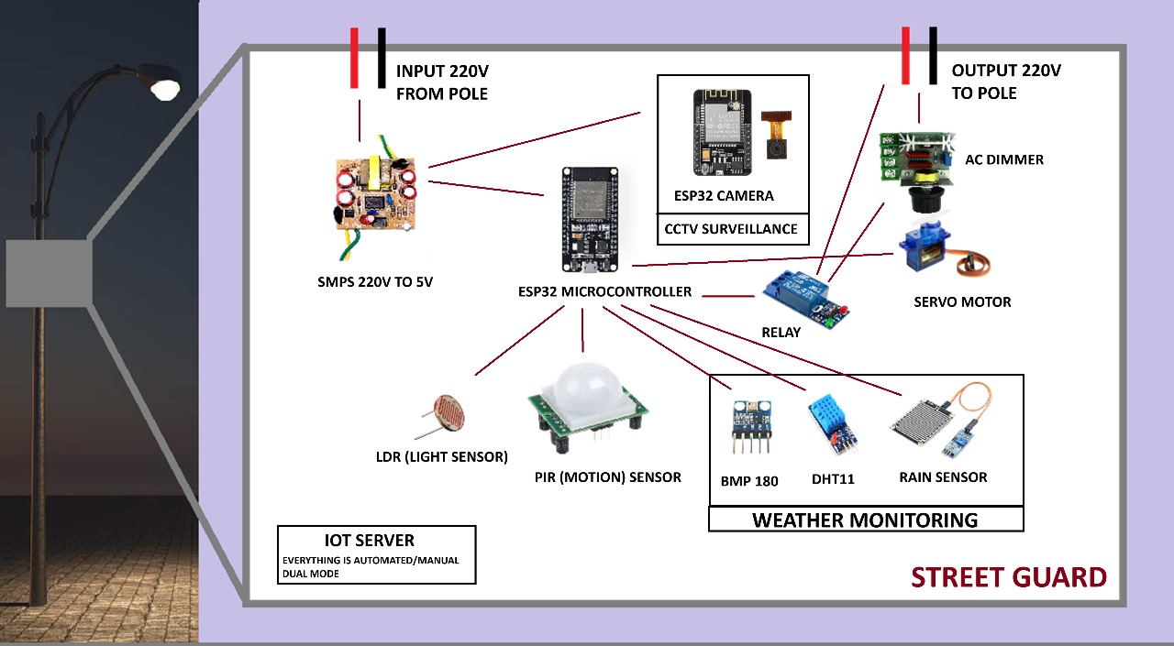

The Street Guard system architecture consists of the following components:

1. **Sensors and Actuators**: The sensors collect weather data and monitor street conditions. The actuators control the street lights and CCTV cameras.
2. **ESP32 Microcontroller**: The microcontroller processes the data from the sensors and controls the actuators. It communicates with the admin panel and IoT server.
3. **Admin Panel**: The admin panel allows administrators to control the system and monitor real-time data. It provides a user-friendly interface for managing the system.
4. **IoT Server (ThingSpeak)**: The IoT server stores and analyzes the data collected by the sensors. It provides real-time data visualization and analytics.

**Data Flow**

The data flow in the Street Guard system can be described as follows:

1. **Data Collection**: The sensors collect weather data and monitor street conditions. The data is transmitted to the ESP32 microcontroller.
2. **Data Processing**: The ESP32 microcontroller processes the data from the sensors. It determines the appropriate actions to take, such as adjusting the street light intensity or sending alerts to the admin panel.
3. **Data Transmission**: The processed data is transmitted to the admin panel and IoT server. The admin panel displays the data in real-time, allowing administrators to monitor the system. The IoT server stores the data for analysis and visualization.
4. **Control Actions**: Based on the processed data, the ESP32 microcontroller controls the actuators. It adjusts the street light intensity, controls the servo motor, and switches the relay on or off as needed.

**Security and Privacy**

Security and privacy are critical considerations for the Street Guard system. The following measures are implemented to ensure the security and privacy of the system:

1. **Data Encryption**: All data transmitted between the sensors, microcontroller, admin panel, and IoT server is encrypted to prevent unauthorized access.
2. **Authentication and Authorization**: Only authorized users can access the admin panel and control the system. User authentication and authorization mechanisms are implemented to ensure that only authorized users can perform actions on the system.
3. **Data Anonymization**: Personal data collected by the system is anonymized to protect the privacy of individuals. The system does not store any personally identifiable information (PII).
4. **Regular Security Audits**: Regular security audits are conducted to identify and address potential vulnerabilities in the system. Security patches and updates are applied promptly to mitigate risks.

**Implementation and Testing**

The implementation and testing of the Street Guard system involve the following steps:

1. **Hardware Assembly**: The sensors, actuators, and microcontroller are assembled and connected. The connections are tested to ensure proper functionality.
2. **Software Development**: The software for the ESP32 microcontroller and admin panel is developed using the Arduino IDE and relevant libraries. The code is tested to ensure it functions as expected.
3. **System Integration**: The hardware and software components are integrated to form the complete Street Guard system. The integration is tested to ensure seamless communication between the components.
4. **Testing and Validation**: The system is tested under various conditions to validate its performance. The sensors are calibrated, and the actuators are tested to ensure they respond correctly to the processed data.
5. **Deployment**: The system is deployed in a real-world environment. The deployment is monitored to ensure the system operates as expected. Any issues identified during deployment are addressed promptly.

**Testing Scenarios**

The following testing scenarios are used to validate the performance of the Street Guard system:

1. **Weather Data Collection**: The sensors are tested to ensure they collect accurate weather data. The data is compared with data from other weather monitoring systems to validate its accuracy.
2. **Street Light Management**: The street lights are tested to ensure they respond correctly to real-time data. The light intensity is adjusted based on ambient light levels and traffic conditions.
3. **CCTV Surveillance**: The CCTV cameras are tested to ensure they provide continuous live feeds. The machine learning algorithms are tested to ensure they correctly identify potential security threats.
4. **Admin Panel Functionality**: The admin panel is tested to ensure it provides real-time data and control options. The user interface is tested for usability and functionality.
5. **System Performance**: The overall performance of the system is tested under various conditions. The system is tested for response time, data processing speed, and reliability.

**Benefits and Applications**

The Street Guard system offers numerous benefits and applications, including:

**Enhanced Safety**

Street Guard enhances street safety by providing accurate weather data, remote street light management, and enhanced CCTV surveillance. The system ensures optimal lighting conditions, improving visibility and reducing the risk of accidents. The enhanced surveillance capabilities improve security, helping to prevent crimes and ensure the safety of pedestrians and vehicles.

**Energy Efficiency**

By dynamically adjusting light intensity based on real-time data, Street Guard significantly reduces energy consumption. This not only lowers operational costs but also contributes to environmental sustainability. The system's ability to adjust light intensity based on traffic conditions ensures that street lights are used efficiently, reducing unnecessary wear and tear and extending their lifespan.

**Real-Time Monitoring**

The admin panel provides real-time monitoring of weather conditions, street light settings, and surveillance feeds. Administrators can monitor the system remotely, ensuring timely responses to any issues. The real-time monitoring capabilities improve the overall efficiency and effectiveness of street management.

**Cost Savings**

The energy efficiency and optimized street light management offered by Street Guard result in significant cost savings. The system reduces energy consumption and maintenance costs, providing a cost-effective solution for street management. The enhanced security capabilities also help prevent theft and vandalism, reducing costs associated with property damage.

**Scalability**

Street Guard is a scalable solution that can be deployed in various environments, from small residential streets to large urban areas. The system's modular design allows for easy expansion and integration with other smart city systems. The scalability of Street Guard makes it an ideal solution for modern urban environments.

**Data-Driven Decision Making**

The data collected by Street Guard can be used for data-driven decision making. The system provides valuable insights into weather conditions, street light usage, and security incidents. This data can be used to optimize street management strategies, improve resource allocation, and enhance overall urban planning.

**Future Developments**

The Street Guard system is designed to be adaptable and upgradable, with several potential future developments:

**Integration with Smart City Systems**

Street Guard can be integrated with other smart city systems, such as traffic management, waste management, and emergency services. This integration can create

**Future Enhancements**

**Advanced Machine Learning Algorithms**

To elevate the capabilities of Street Guard, the incorporation of advanced machine learning algorithms will be a key focus. These enhancements aim to bring predictive and adaptive functionalities that go beyond basic monitoring and control:

* **Predictive Maintenance**: By analyzing historical and real-time data, machine learning algorithms can predict when components such as street lights or sensors are likely to fail. This predictive capability will allow for proactive maintenance scheduling, reducing unexpected breakdowns and ensuring that the system remains operational without interruption.
* **Anomaly Detection**: Advanced algorithms can be employed to identify patterns or anomalies in the CCTV surveillance data. For instance, detecting unusual movement patterns or identifying suspicious behavior can trigger alerts and prompt immediate response from security personnel, thereby enhancing public safety.
* **Traffic Flow Optimization**: Machine learning models can analyze video feeds and sensor data to assess traffic patterns and congestion levels. This analysis can lead to dynamic traffic management strategies, such as adjusting traffic signal timings in real time to alleviate bottlenecks and improve overall traffic flow.

**Integration with Other Smart City Systems**

The integration of Street Guard with other smart city systems represents a significant opportunity for synergy and improved urban management:

* **Traffic Management Systems**: By integrating with traffic management infrastructure, Street Guard can provide real-time data on street lighting and weather conditions. This information can be used to optimize traffic signal timings and manage traffic congestion more effectively, leading to smoother traffic flow and reduced travel times.
* **Emergency Response Systems**: Connecting Street Guard with emergency response systems can enhance situational awareness for first responders. Real-time data from weather sensors, CCTV cameras, and street lights can be utilized to assess the situation and plan responses more accurately, ultimately improving emergency response times and effectiveness.
* **Public Information Systems**: Integration with public information systems will enable the dissemination of critical updates to residents. For example, real-time weather alerts, traffic updates, and security notices can be broadcasted through digital displays, social media platforms, and mobile apps, keeping the public informed and engaged.

**Scalability and Expansion**

Scalability is crucial for Street Guard to accommodate the growing needs of urban environments. Key areas of focus for future scalability and expansion include:

* **Modular Design**: Street Guard will adopt a modular approach, allowing for the easy addition of new sensors and components. This flexibility ensures that the system can evolve with technological advancements and integrate new functionalities as they become available.
* **Cloud-Based Architecture**: To handle increased data volumes and processing requirements, Street Guard will leverage a robust cloud-based architecture. This approach ensures that data can be stored, processed, and analyzed efficiently, regardless of the scale of deployment. Cloud integration will also facilitate remote access and management, enhancing the system's usability.
* **Geographical Expansion**: Adapting Street Guard for different climates and urban layouts will make it applicable to a variety of cities worldwide. Customization options will be developed to cater to regional requirements, such as extreme weather conditions or specific urban challenges, ensuring that Street Guard remains effective and relevant across diverse environments.

**Conclusion**

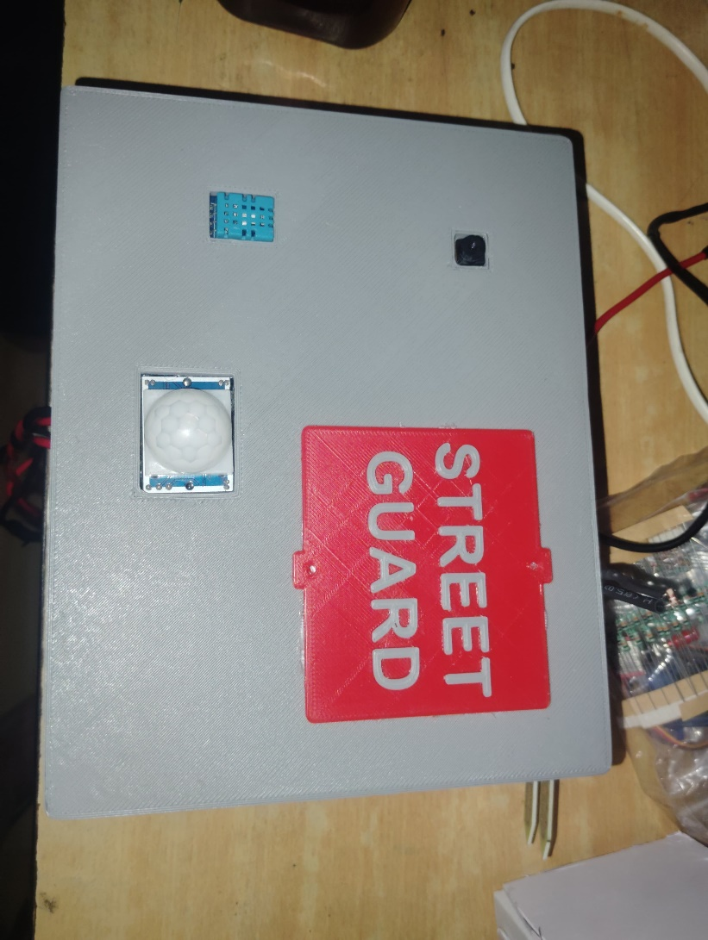

Street Guard stands as a pioneering solution in the realm of smart street management, combining IoT technology, cloud computing, and machine learning to address the multifaceted challenges of modern urban environments. Through its accurate weather monitoring, remote street light management, and enhanced CCTV surveillance, Street Guard delivers a comprehensive approach to improving street safety and efficiency.

Looking ahead, the integration of advanced machine learning algorithms will bring predictive capabilities and anomaly detection, further enhancing the system's responsiveness and reliability. By connecting with other smart city systems, Street Guard will foster greater coordination and efficiency across urban management efforts. Scalability and expansion plans will ensure that Street Guard remains adaptable and effective as cities grow and evolve.

In essence, Street Guard is not just a technology solution; it represents a forward-thinking approach to creating safer, smarter, and more sustainable urban environments. As the project continues to develop and integrate new features, it will play a crucial role in shaping the future of smart cities, delivering innovative solutions that meet the dynamic needs of urban populations.